**HM/TM L6**

THE HOTEL & HOSPITALITY INDUSTRY  
THE TOURISM & TRAVEL INDUSTRY  
**ONLINE**

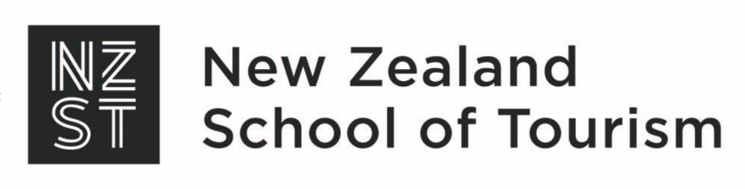

THE HOTEL & HOSPITALITY INDUSTRY

THE TOURISM & TRAVEL INDUSTRY

HM: New Zealand Diploma in Hospitality Management Level 6

TM: New Zealand Diploma in Tourism and Travel Level 6

**[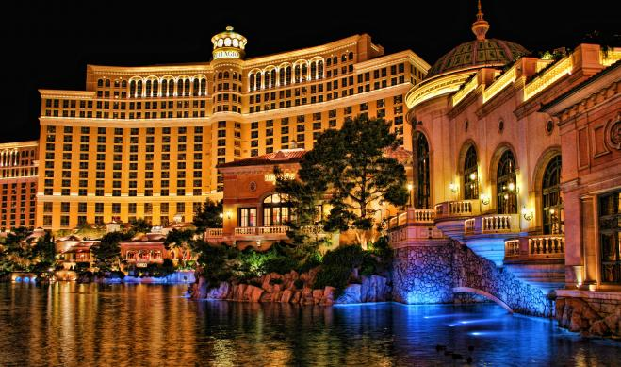](http://www.google.co.nz/url?sa=i&rct=j&q=&esrc=s&source=images&cd=&ved=2ahUKEwi-r93m-sLdAhWLU7wKHcQUBFwQjRx6BAgBEAU&url=http://neuralseed.com/transport.php&psig=AOvVaw3FC9atBdVAuoRqArCyGfMn&ust=1537304838415647)ONLINE** STUDENT WORKBOOK

© Copyright 2019 New Zealand School of Tourism Ltd

These notes have been prepared especially for the students of New Zealand School of Tourism Ltd. All rights reserved. This publication constitutes intellectual property of New Zealand School of Tourism Ltd. This workbook is copyright. No part may be reproduced, stored in a retrieval system, or transmitted, in any form or by any other means, electronic, mechanical, photocopying, recording or otherwise without permission. Inquiries should be made to Head Office.

COURSE 1: THE HOTEL AND HOSPITALITY INDUSTRY

MODULE: THE HOTEL AND HOSPITALITY INDUSTRY

CREDITS: 10

LEVEL**:** 6

|  |  |  |
| --- | --- | --- |
| Graduate profile 5 | Learning Outcomes | ASSIGNMENT |
| Plan and develop future business strategies that encompass financial management, product development, sales and marketing and continuous improvement processes in a hospitality environment. | LO 1.1  Analyse the state of the New Zealand hospitality industry (Cr3)  LO 1.2  Analyse a range of national and international trends in product development in Hospitality. (Cr2) | **HM: The Hotel & Hospitality Industry**  An **open book, online written** assignment.  Task 1  Write a short report that analyses the state of the New Zealand hospitality sector.  (GP5, Cr3)  Task 2  Write a report that analyses two trends that have enabled New Zealand to remain resilient during the global Covid-19 pandemic.  (GP5, Cr2)  (GP4, Cr5) |
| GRADUATE PROFILE 4 | Learning Outcomes |
| Select and apply a range of strategic solutions, in response to changes in the hospitality business environment, in order to maintain or improve hospitality business performance. | LO 1.3  Analyse and evaluate trends related to strategic responses to change and how this has shaped the direction of the industry. (Cr5) |

COURSE 1: THE TOURISM AND TRAVEL INDUSTRY

MODULE: THE TOURISM AND TRAVEL INDUSTRY

CREDITS: 10

LEVEL**:** 6

|  |  |  |
| --- | --- | --- |
| Graduate profile 1 | Learning Outcomes | Assignment |
| Analyse and evaluate local, national, and international tourism operating environments in order to effectively develop and guide strategic direction of a business in the tourism industry. | LO 1.1  Analyse the state of the New Zealand tourism industry.  (Cr3)  LO 1.2  Analyse a range of national and international trends in the operating environment of the tourism and travel industry.  (Cr2)  LO 1.3 Analyse and evaluate trends related to strategic responses to changes and their impacts on the industry.  (Cr5) | **TM: The Tourism & Travel Industry**  An **open book, online written** assignment.  Task 1  Write a short report that analyses the state of the New Zealand hospitality sector.  (GP5, Cr3)  Task 2  Write a report that analyses two trends that have enabled New Zealand to remain resilient during the global Covid-19 pandemic.  (GP5, Cr2)  (GP4, Cr5) |

table of contents

the current state of New Zealand tourism 1

growth of New Zealand tourism, hotel & hospitality companies 4

**Industry boom: Over 120 hotels proposed   
for NZ 5**

sdl Regional overview 8

Economic importance of tourism   
and hospitality 9

Working with chinese travellers 12

**Chinese seeking tailor-made travel to New Zealand 13**

**SDL 16**

Operating environments 17

Economic Profile 18

Responding to change 22

**SDL 25**

Case study: 26

Patterns and trends in leisure and tourism 26

**Societal variation in leisure time 28**

**Reasons for the growth in tourism 32**

Case study: 33

Lime Scooters 33

How to write a case study 35

the current state of New Zealand tourism

In 2017, according to the New Zealand Tourism Industry Report, tourism business confidence levels were strong, with most operators expecting improvement in their businesses throughout the year and to continue in the future.

The New Zealand tourism industry runs a survey on the state of New Zealand tourism each year. In 2017, 354 tourism operators from all over New Zealand were surveyed in relation to the industry’s performance over the last 12 months. It provides a scorecard on how the industry is tracking to reach its goal of $41 billion total annual tourism revenue as proposed by the New Zealand Tourism 2025 framework.

Of the tourism businesses surveyed, 62% believed performance is expected to improve over the next 12 months with 74% wishing to attract high-value visitors to their businesses. According to the 2017 tourism scorecard, in 2017 visitor experience was maintained with 93.4% of international visitors having their expectations met or exceeded. In 2017, international seats and domestic seats on flights made strong progress with 10 million international seats being sold and 16.2 million domestic seats sold. Productivity for the dispersal of international tourism spending showed there was no progress, dropping by 1% from 2016. The arrivals of international visitors by season remain like previous years.

Another area to see an increase was the percentage of people directly employed in tourism. In 2017, this accounted for 8.4% of the total number of people employed in New Zealand which is an increase of 9.3% from 2016. If it continues in this direction it means more opportunities for industry roles as well as more opportunities for businesses to grow.

Overall, tourism in New Zealand is improving each year, businesses are becoming more knowledgeable about the variety of markets and how to tap into those markets. They are also more mindful about how to improve their business growth during the quieter seasons.

Though the survey showed visitor satisfaction results were very strong, there was still a slight decline from the previous year. These were in relation to cost and quality of accommodation, food and beverage outlets, convenience and cost of public transport, cost of activities access to Wi-Fi etc.

Comments from the survey also highlighted the need to improve the road infrastructure as this was shown to have a negative impact on the visitor experience in such areas as Northland, Coromandel, Hawke’s Bay and elsewhere.

A barrier to tourism success that was highlighted was the country’s infrastructure. Our 100% Pure New Zealand image needs to be maintained and infrastructure plays a key part. Ensuring that walkways and cycleways are well maintained as these encourage a healthy lifestyle highlighting our green environment. However, other areas of high importance to the success overall of the nation is improvement of roads, toilet facilities, water, tourism sites and attractions being of high quality and well maintained and all tourist areas are clean and safe.

Domestic tourism also increased by 4% with tourism expenditure of $21.4 billion. The domestic market has a great potential to add value to the New Zealand tourism ministry and significantly contributes to regional economies.

The perception of tourism New Zealand from the public overall is positive with 96% of New Zealanders agreeing or strongly agreeing that international tourism is good for New Zealand. Tourism creates positive economic benefits for the country and brings business opportunities, employment opportunities and economic growth to the regions.

The State of the Tourism Industry documents are updated regularly so ensure you check for the most up to date information.

Source: Adapted from [Tourism 2025](http://tourism2025.org.nz/assets/Uploads/State-of-the-Tourism-Industry-2017-final.pdf).



Answer the following with a short paragraph:

1. What possible reason(s) could have impacted the slight decline in international visitor satisfaction ratings?

1. Based on the reasons you have provided above, what actions could be undertaken to improve this rating for the next 12 months and why?

growth of New Zealand tourism, hotel & hospitality companies

The performance of the hotel industry in New Zealand is continuously improving, with record occupancy rates and room rates being achieved. Currently, the outlook for growth in this area is high both nationally and regionally. Increased visitor numbers to both Queenstown and Auckland, two of the country’s main tourism destinations, has shown a need for new hotel investment bringing more business opportunities. Currently there are hotel development projects and plans in both areas, but demand is growing faster than the expected demand for rooms.

Room rates in New Zealand are considered reasonably cheap by international standards and though they are rising strongly, the rates are not yet high enough to warrant or make viable new hotel projects. However, some of the world’s biggest hotel names are looking to New Zealand as the increase in tourism demand has brought interest from international chains. With high end brands buying New Zealand hotels it has meant other hotels also having to respond by refurbishing to keep their place in the market.

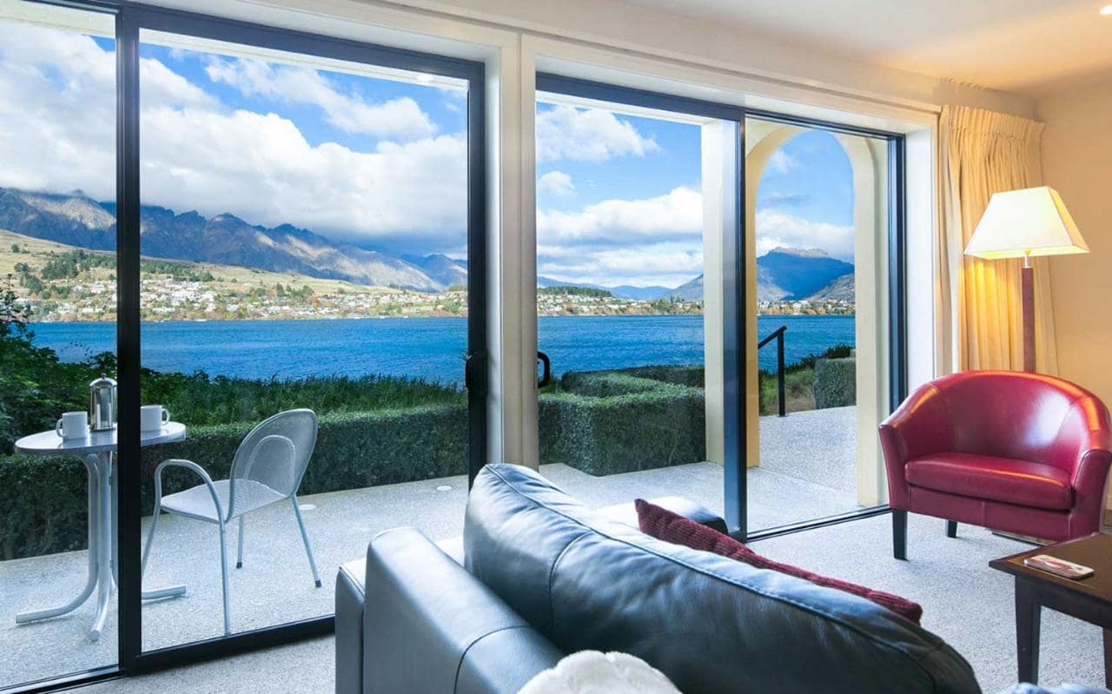

Industry boom: Over 120 hotels proposed for NZ

New Zealand's hotel industry is experiencing a boom in investment which the country has not seen for decades, a tourism insider says.

Members of the country's hotel industry are due to meet at their annual conference in Auckland next week, to discuss the state of the sector, including the growing demand for more hotels around the country to cater to visitors.

The 2018 New Zealand Hotel Industry Conference is the largest event for the country's hotel sector, run by Tourism Industry Aotearoa (TIA) which represents the interests of nearly 170 members throughout New Zealand.

TIA hotel sector members employ 10,800 staff nationally, with annual revenues of more than $1.17 billion.

Its chief executive Chris Roberts said despite the boom, the industry could not stand still.

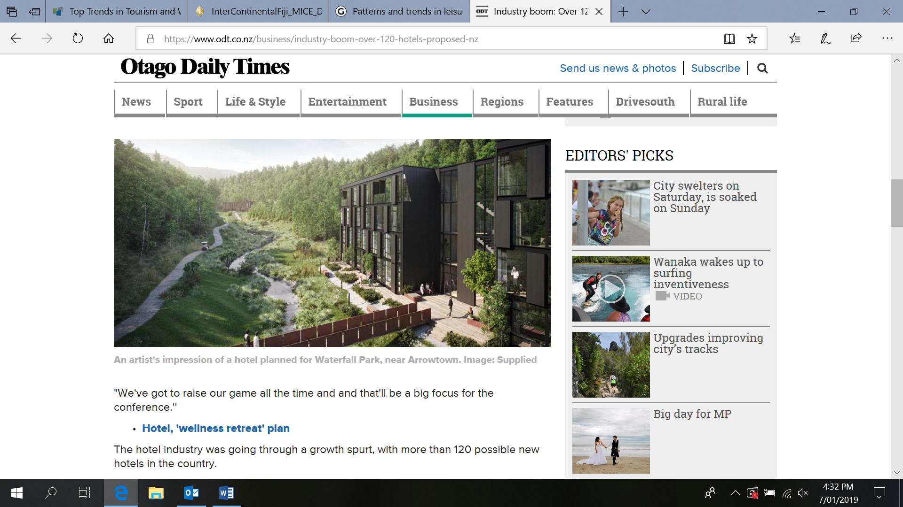

**An artist's impression of a hotel planned for Waterfall Park, near Arrowtown.**

"We've got to raise our game all the time and that'll be a big focus for the conference.''

The hotel industry was going through a growth spurt, with more than 120 possible new hotels in the country.

"There's a degree of hotel investment that we haven't seen possibly in decades. Of the existing hotels, almost all have been refurbished or are being refurbished and upgraded and there's a lot of interest in building new hotels.''

Part of the challenge for the sector was how to encourage hotels in other towns which were emerging, rather than traditional tourist hotspots.

"Investors are understandably a little bit cautious and really need convincing that an area is going to have a volume of visitors to justify that sort of investment.''

He said the recent announcement of a new hotel being built in Kaikoura was good news, and a sign that businesses had confidence in the town's future post-earthquake.



**Artist's impression: The hotels and apartment buildings. Anthony Tosswill is involved in part of the $200million hotel complex with more than 550 rooms, the latest mega development planned for Queenstown.**

Investors were looking to build in Tekapo, Ashburton, Dunedin, Wanaka and Blenheim.

"Certainly, for an investor looking to manage their risk they're still attracted to those centres like Auckland, Wellington and Queenstown and that will always be the case.''

Another challenge for the hotel industry was staffing, which he called a "continual headache''.

The hotel sector still had a great reliance on migrant workers.

"We have to keep doing more to attract New Zealanders, but we also need to keep that pipeline open to use workers from overseas.''

Competition from Airbnb was not an issue, however.

"Airbnb is growing about 100 percent a year in terms of properties on offer but with the tourism growth we've seen it's been absorbed and hasn't had a detrimental impact on the hotel sector.

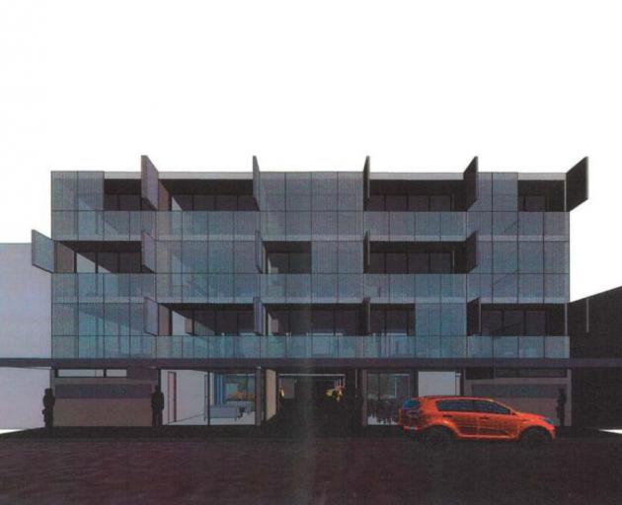

**An architect’s drawing of the proposed 27-room hotel in Filleul St, which has been approved by the Dunedin City Council.**

"I'd say it's probably had a bigger impact on the motel sector as there's more direct competition.''

But that might not last: "If we had a tourism downturn, which will inevitably happen at some point, the squeeze may come on at that point for the visitor market."

"But at the moment Airbnb has helped with capacity. If all these hotels get built and visitor numbers drop, then it may get more competitive.''

The government's proposed tourism tax is also not the biggest concern for the sector but the targeted rate, he said.

Mr Roberts said a big focus for the industry at the conference this week would be on continuing to raise the sector's standards. "Visitors are increasingly looking for higher standards.''

Source: https://www.odt.co.nz/business/industry-boom-over-120-hotels-proposed-nz

sdl  
Regional overview

Each region has its own RTO who are responsible for the promotion and marketing of their region to both domestic and international visitors. They are the specialists providing information on their region and local tourism products and work closely with the i-SITE located throughout New Zealand.’

Research the current state of tourism in your region or city and provide an overview of it. Ensure to incorporate developments in tourism in the area, what growth has there been? What have the visitor numbers been in the last 12 months for both international and domestic visitors to your area?

Write this in a short report to be delivered in class in the next day’s session.

Economic importance of tourism and hospitality

The travel, tourism and hospitality industries all enrich New Zealand and is the backbone of many communities. Tourism is an increasingly competitive market and for New Zealand, we can be marketed as a niche destination. To enable this to happen New Zealand needs to ensure it attracts high value visitors by highlighting our uniqueness, and that is our people and culture alongside the landscape and scenery, the 100% Pure New Zealand image.

All of these make up New Zealand’s essence, the brand, and currently it is very strong, and this is clear in the increase in international visitor numbers. Tourism New Zealand is working with Māori Tourism and a range of stakeholders to incorporate people and culture into New Zealand’s destination brand.

“It’s incredibly important we get this right. Our people and culture are diverse and multifaceted, and we need to make sure we capture this authentically and deliver something Kiwis will embrace.” – Tourism New Zealand’s chief executive Stephen England-Hall

In the year ending May 2018, international visitor numbers to New Zealand increased by 5.3%, with holiday visitors increasing by 6.5%. There was also a 5.6% increase on the previous year for off peak visitors. These increased arrival numbers importantly meant a regional spend of 14.1% with international visitors spending $497 million into the regions in the last 12 months. Beyond the economic benefits, the significant rises in visitor arrivals means industry growth, more employment and business opportunities increase.

In 2018 $96.6 million worth of business events was secured by Tourism New Zealand. The business events sector has a huge potential and is an excellent way of showcasing New Zealand. Growth in this area shows the high level of hospitality we have to offer on the world stage.

The 40 international conferences and 47 incentive programmes were secured over the last 12 months across New Zealand meaning the benefits of these business events will reach far and wide, including neighbouring regions. Another benefit being the expert knowledge shared and contributed by the conference delegates helping our local areas to grow and improve. These are high value visitors and to ensure growth we need to continue to attract them to New Zealand.

Economic benefits of cultural diversity

Through surveys, it has shown that overall New Zealanders tend to be in support of cultural diversity and continued immigration.Recent studies have indicated how cultural diversity works through the economy to society in areas such as from tourism.

International business within a globally connected marketplace

Recent research investigating the impact of cultural diversity has focused on migrant populations, including the productivity, labour participation and taxation revenue benefits of immigration. But research examining the benefits of cultural diversity on business operations in more general terms has found a positive relationship between having diverse staff members and the performance of multinational corporations. Culturally diverse staff members, particularly migrant workers, may have international connections aiding the flow of labour, goods, services and knowledge between New Zealand and their nation of cultural heritage. Other potential benefits include lowering barriers to entry for new culturally diverse talent in an organisation and increasing markets with increasingly culturally diverse populations.

Tourism

As the tourism industry has moved towards ‘niche’ and cultural tourism, cities have developed what has been termed ‘ethnic quarters’ to broaden their tourism offer and capitalise on the desire for new and varied cultural experiences. Cultural events and festivals in ethnic quarters have become successful drivers for tourism to cities, increasing visitation and visitor spend. Constructed cultural precincts (such as Chinatowns) and organic clustering of cultural groups that have limited tourism infrastructure (such as Harlem in New York City) provide tourism benefits to culturally diverse cities and provide a competitive advantage with competing tourist destinations.

Hospitality and the food industry

Cultural diversity provides increased choices for cuisines and dining options, for residents and visitors alike. Exposure to culturally diverse foods and cuisines can also provide potential for diversification and creativity within the hospitality industry, as seen in the rise of fusion cuisines and restaurants. Food is often the first point of contact and exposure to different cultures.

Other research has found activities relating to food to be the most successful events in bringing culturally diverse community members together. Food enhances the likelihood of positive cultural interactions between culturally diverse groups, which in turn enables the development of a foundation for social cohesion and cultural exchange across a culturally diverse community.

****Source adapted from : https://www.sgsep.com.au/publications/economic-benefits-cultural-diversity****



1. Write a paragraph expanding on why New Zealand is a niche market? What make is unique?
2. What does economic growth mean for the regional areas of New Zealand?

Working with chinese travellers

The Chinese market is the second largest international market to New Zealand. The Chinese are also starting to move away from organised tours and become FIT as they gain confidence in organising their own trips. They are looking for fresh and unique experiences and are wanting to visit more regional areas than the main tourist hubs.

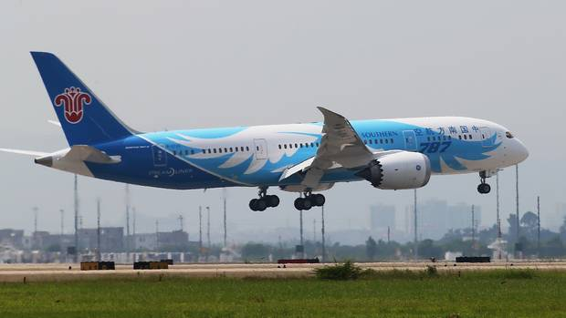

With a significant increase in air capacity from China, tourist numbers have been boosted. Over the last year the kiwi dollar has shown a fall of 9% against the Chinese Yuan meaning the Chinese tourist market is not only booming but they also have higher spending power. The total spend from Chinese tourist has increased by 14% (up by more than $1.6 billion) in the last 12 months and with increased flights and capacity from Shanghai, Beijing, and Guangdong province (with the cities of Guangzhou and Shenzhen) Chinese visitors have more accessibility to New Zealand.

Visitors direct from China have grown considerably for the year ended September 2018, rising 21 per cent (up 14,600), 11.3 per cent (up 7,600) and 16.3 per cent (up 3,600) respectively. The Chinese market is looking ready to continue its growth into New Zealand with further airline routes opening.

The Chinese market has previously seen visitors coming for very short 3-4-day trips and this has steadily begun moving towards to slightly longer trips of 1-2 weeks.

More than 453,000 Chinese visited New Zealand in the last year.

According to official figures, Chinese tourists made 130 million overseas trips in 2017 and in the first six months of 2018, Chinese visits abroad reached 71.31 million, a 15 percent increase from 2017.

Overall, the spending from international visitors to New Zealand increased by 7% ($11 billion) with the average spend per visitor also increasing up to 4% ($3300) for the year to September 2018.

Chinese seeking tailor-made travel to New Zealand

Tourism New Zealand has hosted the first ‘New Zealand Tailor-Made’ event in China, promoting the emerging trend of tailor-made travel to New Zealand.

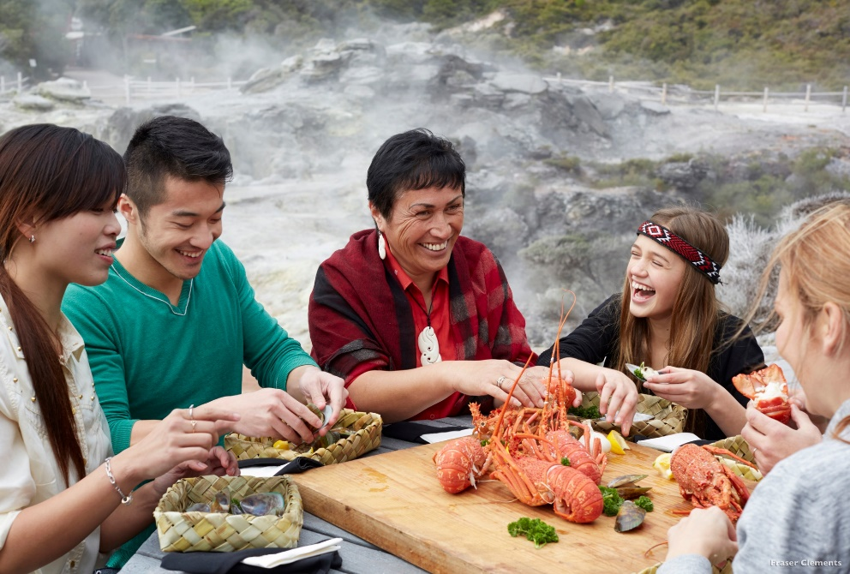

Tourism New Zealand’s General Manager - Asia, Gregg Wafelbakker, says the growing trend for tailor-made travel from China will be valuable to the tourism industry and well-aligned with New Zealand’s tourism aspirations.

“Tailor-made travel is an emerging trend in China due to an increasing demand for in-depth travel by consumers who don’t have the time to plan their own itinerary but are willing to pay for a quality experience,” says Mr Wafelbakker.

“Through tailor-made travel, clients can create a wish-list for their holiday and travel agents will design a comprehensive, bespoke itinerary for that trip – from flights right through to accommodation, activities and on-the-ground travel.”

Tailor-made travel is a significant shift from the large group tours traditionally seen from the China market. Tour groups now make up just 34 % of Chinese visitors, down from 41 % in 2017. Free and Independent Travellers (FIT) now make up 40 % of Chinese visitors, up from 31 % in 2017.

“Tailor-made travel gives Chinese visitors the structure of an organised tour with the freedom to experience more of what New Zealand has to offer,” says Mr Wafelbakker.

“With the expert guidance of tailor-made travel agents, visitors can easily and confidently experience more of New Zealand’s regions with every aspect of the travel arranged for them in advance.”

New Zealand is considered well set up to fulfil the requirements of tailor-made travel visitors.

“Consumers of tailor-made travel are typically looking for unique experiences, variety and flexibility in their holidays,” says Mr Wafelbakker.

“New Zealand is the perfect destination for tailor-made travel, with varied landscapes and experiences always just a short distance away – you could be skiing in the morning, whale watching in the afternoon and star gazing in a dark sky reserve in the evening.”

Tourism New Zealand is the first national tourism organisation to host an event introducing tailor-made packages and resources to the industry in China. The events attracted 160 travel agents specialising in tailor-made travel across Beijing and Shanghai.

Tourism New Zealand was joined by Ngai Tahu Tourism who showcased a variety of New Zealand tourism products. Ngai Tahu also shared their experience hosting and tailoring their products to the recent Amway China incentive group visit.

China is New Zealand’s second largest tourism market with around 340,000 holiday visitors each year, contributing almost $1.3B to New Zealand’s economy.

Source: https://www.tourismnewzealand.com/news/international-business-events-enrich-new-zealand/

1. 

Read through the following article, which will be supplied by your trainer, and identify the commonalities and differences between this article and the one above.

Sun M., Zhang, X. and Ryan C. (2014). Perceiving tourist destination landscapes through Chinese eyes: The case of South Island, New Zealand. Tourism Management: 46, 582-595

SDL

Research another international market and identify the specific needs of the market and how New Zealand caters to them. Provide a minimum of three examples.

Operating environments

The operating environment of a company is influenced by a combination of internal and external factors. For example, seasonality and changes in the global economy have an impact on profitability and development opportunities within the tourism industry. There are some good examples of tourism organisations that have taken the initiative to change their business practices as well as their operating environment. They have learned to live according to their operating environment. instead of being reactive to their operating environment and changes taking place in it, they have chosen to foresee, respond, influence and adapt to the changes.

Other factors that impact the operating environment of a business include:

* Clients and suppliers
* Competition and owners
* Trends in technology e.g. Virtual Reality (VR)/Augmented Reality (AR),360 images and apps etc.
* Regulatory requirements
* Market conditions
* Social and economic trends
* Associated hospitality services
* New transportation modes e.g. low-cost carriers
* Sustainable development
* Environmental impacts



In small groups, investigate and provide an example of an operational element for a hospitality or tourism business in relation to the element you have be given. Your trainer will provide you with the operational element to investigate.

Economic Profile

We’ve built the tools to tell Auckland’s economic story and pave the way for future growth

Read through the following information and look online at the website provided.

Auckland Tourism, Events and Economic Development, (ATEED), has just released two new data tools designed to improve understanding of Auckland’s economy, how it’s performing and the unique role it plays in New Zealand’s broader economy. **Auckland's economic profile:**

[https://bit.ly/2XtKioG](https://bit.ly/2XtKioG%20)

These tools, which have been created through the hard work of a number of my colleagues, are more than a collection of the latest available data for the city put together in an easy to understand and user-friendly format. They play a critical role in helping us tell Auckland’s economic story, recognising that despite being New Zealand’s only global city, we tend to be known more as a destination and quality of life city, regularly appearing near the top of several global indices.

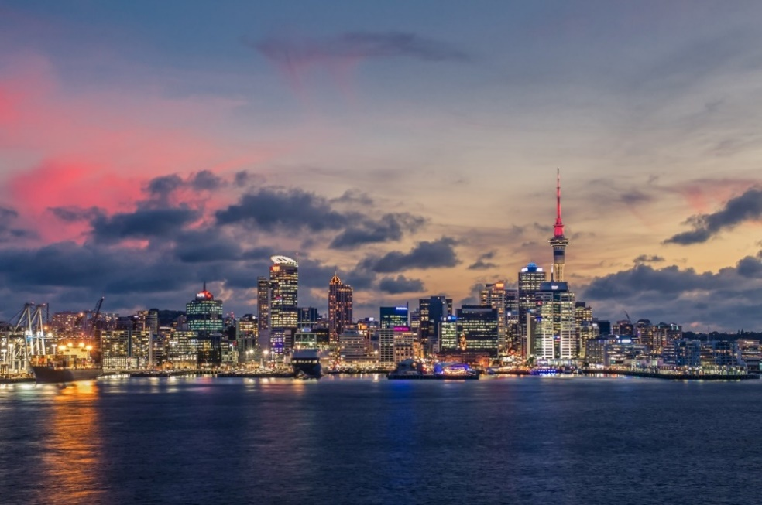Building an awareness of the city as more than a destination is critical for Auckland and New Zealand’s future competitiveness. Auckland needs to be known as a centre for business, a centre for innovation, and a centre for investment. This is essential if we are to grow more companies of scale that can compete in international markets and if we are to grow, attract and retain the skills and talent that our businesses need to prosper.

While much of the data contained in the Auckland Growth Monitor and Index isn’t new, seeing it all in one place, tells a compelling story of how much Auckland has changed since the creation of the ‘super city’ in 2011, an event which arguably contributed to Auckland’s emergence as a ‘New World City’.

While growth has undoubtedly put significant pressure on the city’s infrastructure, it’s perhaps worth remembering that the pace and amount of infrastructure investment has increased dramatically since pre-amalgamation days, and the current infrastructure deficit is not simply down to the recent growth of the city. It is also the result of decades of underinvestment in the basics that a city like Auckland needs to compete on a global stage.

However, infrastructure pressures aside, Auckland’s overall economic story since amalgamation is a positive one. Auckland’s economy plays a central role in New Zealand’s overall economic story. The city represents 34% of New Zealand’s total population, but 38% of the country’s economic output, measured by Gross Domestic Product (GDP). Auckland’s industrial structure is different from the rest of New Zealand’s, and while Auckland accounts for over a third of the national economy in total –for some key sectors including technology, commercial services, creative and screen – it is nearer to 50%. This is important, as many of these sectors fall within the Advanced Industries, which have been growing faster, are export oriented and add more and better jobs than other non-Advanced Industry sectors.

As New Zealand’s only global city, Auckland has some unique characteristics that are not present in other urban areas. Auckland is younger and more diverse that the rest of New Zealand, with 39% of Aucklanders born overseas and the city is home to more than a third of all Maori in New Zealand. Auckland is home to the largest urban Pacific people’s community in the world. With forecast ongoing inward migration, Auckland is projected to become even more diverse.

Auckland is New Zealand’s international gateway, not simply in terms of visitation, where 78% of international arrives to New Zealand are received by Auckland Airport, but also in terms of migration, international students and the attraction of multinational enterprises to New Zealand. Auckland’s population is growing faster than the New Zealand average and Auckland’s recent growth has been fuelled by international migration. Auckland is the majority contributor to the growth and success of New Zealand’s international education sector, some 63% of all international students reside in Auckland. From a business perspective, over 100 multinationals have their Asia Pacific headquarters in Auckland.

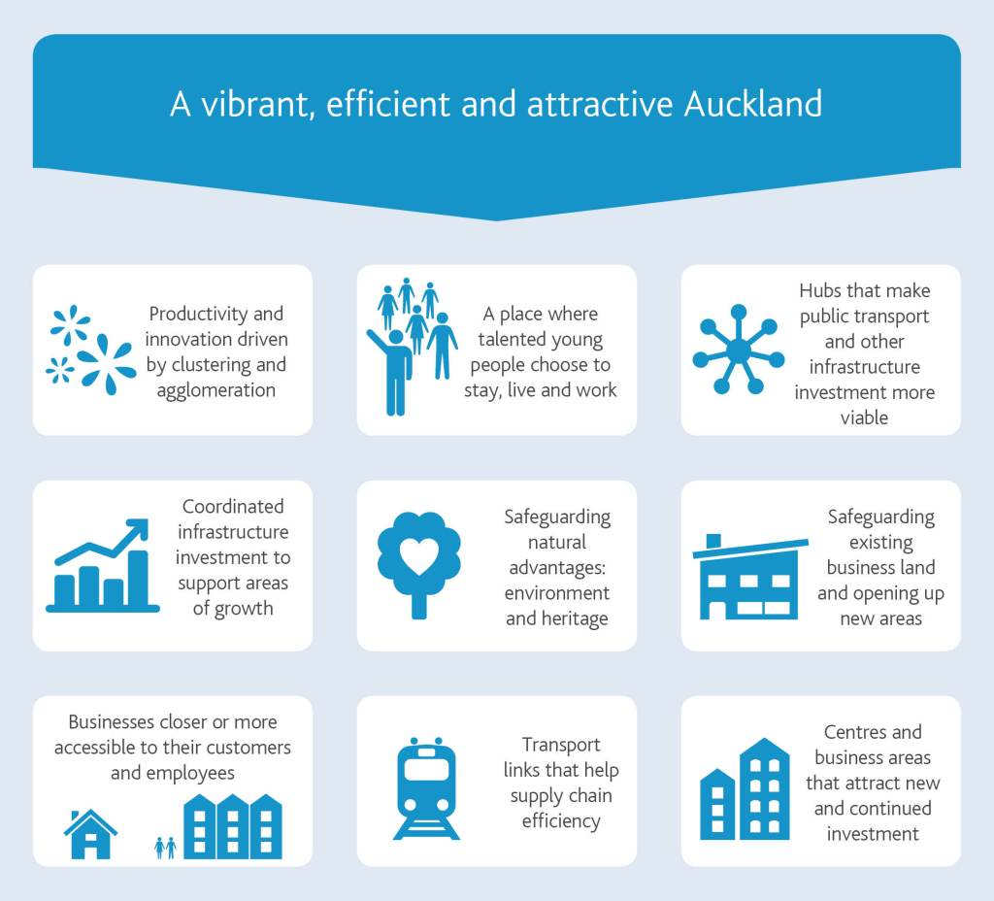

Auckland’s scale means that it realises agglomeration benefits that aren’t felt elsewhere in the country. Auckland’s population is more highly skilled than rest of New Zealand, with 36% of Auckland’s population being highly skilled up from 28% in 2011. Auckland is also adding new jobs. Between 2011 and 2016 more than 94,000 new jobs were created, and the unemployment rate now sits at 4.7% compared 6.6% in 2011.

Auckland also plays an important role in trade, contributing a significant proportion of New Zealand’s total exports, with 24% ‘goods exports’ but 42% ‘services exports’ originating from Auckland. Major exports include Food and Beverage, and Tourism from a service perspective, which is a major export revenue generator.

This is not to say that Auckland does not face some economic challenges. While growth has been strong, it has not all been inclusive. Youth employment remains a challenge with 13.3% of 20-24 year olds unemployed, and while Maori employment grown by nearly 22%, the unemployment rate for Maori is still over 10%. Maori also represent 24% of Auckland’s young people who are Not in Education, Employment or Training (NEET), with 6,600 Maori aged 15-24 years classified as NEET, which means 21% of all Maori youth are NEETs. Also, while GDP growth has been higher in Auckland than rest of New Zealand, low productivity per capita is Auckland’s biggest economic challenge and one which continues to hold back efforts to increase prosperity across the city.

Given the size and nature of Auckland’s economy any national policies need to work for Auckland if New Zealand is to move forward. For example; if you look at the scale of Auckland’s youth unemployment challenge, you will only improve the overall New Zealand position if you can make a difference in Auckland. Similarly, given Auckland’s overall importance to New Zealand’s economy, any uplift in productivity in the city will generate significant returns for New Zealand as a whole. Finally, there is also a need for national policy to recognise the distinctive elements of Auckland’s economy that need to be considered in national policies, even where they are not as relevant elsewhere in the county. Auckland’s commercial services sector and the dominant role the city plays in service sector exports would be one important aspect.

Source: https://www.linkedin.com/pulse/weve-built-tools-tell-aucklands-economic-story-pave-way-mcveigh



Using the information from this article summarise the key points about how Auckland’s economy is performing. And give your opinion on one of the mentioned aspects.

Responding to change

The travel, tourism and hospitality industries are faced with a constantly changing environment and need to be able to adapt to change by responding quickly.

There is a large array of reasons for change, technology, environment, competition as well as other factors such as terrorism, political/civil unrest and health epidemics as these have a big impact on tourist numbers.

Airbnb

This company was founded through noticing a gap in the accommodation sector. Brian Chesky and Joe Gebbia had recently moved to New York and had noticed that with a conference on in the city all of the hotel rooms were booked out, but delegates still needed accommodation. So, they bought some air beds and made a quick website to advertise “Air Bed and Breakfast.”

The idea was to offer visitors a place to sleep and breakfast in the morning. They charged $80 each a night. The idea succeeded, and the first Airbnb guests were born: a 30-year-old Indian man, a 35-year-old woman from Boston and a 45-year-old father of four from Utah sleeping on their floor.

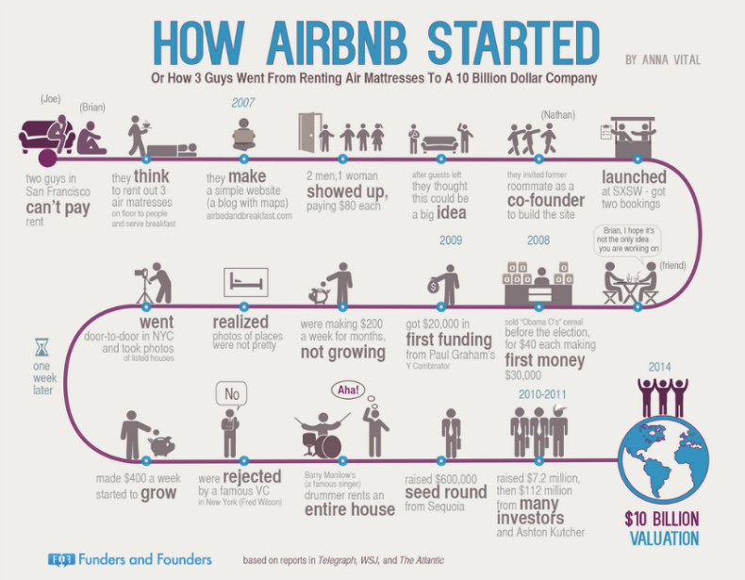So, this idea came through noticing a need for accommodation and then grew from there developed into a billion-dollar company all through responding to change in customer needs for somewhere to stay.

Check the full story on their website: <https://getpaidforyourpad.com/blog/the-airbnb-founder-story/>   
or short URL: https://bit.ly/3FzOXqk

Dual-Branding Hotel Trends

While dual-branding a hotel is not new, it has certainly grown in popularity over the last few years.

Dual-branded hotels are simply two branded hotels generally in a single structure run by the same operator. The two brands that comprise the hotel can be either “linked” or “blended.” Linking occurs when the properties share minimal components (limited to areas such as parking, swimming pool, fitness area, or back-of-house operations). Blending results in further integration, such as combined breakfast areas, lobbies, front desks and hotel staff.

[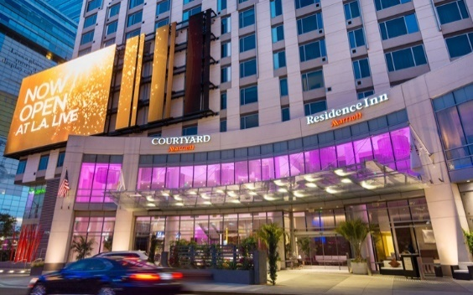](https://www.google.com/url?sa=i&rct=j&q=&esrc=s&source=images&cd=&cad=rja&uact=8&ved=2ahUKEwjcnI38n-rfAhUF448KHVxfAr4QjRx6BAgBEAU&url=http://www.hotelnewsnow.com/Articles/40994/Twos-company-Owners-see-benefits-in-dual-brand-hotels&psig=AOvVaw1Mea2njDmlVCX_5QulPOUn&ust=1547451430443799)  
The advantages to an investor or developer with a dual-branded hotel is the likelihood of significant cost savings when only having to develop a single amenity or component within the hotel. The saving can even begin prior to construction with decreased costs related to plans, permits, fees and entitlements. For these reasons, developers generally prefer to do as much blending as possible. However, because these properties are usually the opposite of prototypical construction, additional costs can accumulate when significant specialised design, development and construction are required. Regardless of the level of savings during development, long-term cost savings can be realised by the operator when they are able to combine management, facilities, sales and administrative offices.

The primary drawbacks to dual branding are more likely to be expressed by the franchisor, or even some guests. Brands invest significant time and money to create a strong brand identity, which in the best case scenario leads to strong brand loyalty in their customers. A customer who seeks out a Hilton Garden Inn, for example, may be disappointed if they do not encounter the customary Pavilion, but instead are greeted by the Homewood Suites Lodge motif. For this reason, Hilton generally requires separate entrances and lobbies for their dual-brand hotels.

When one of the two brands are at a higher price tier, the hotel runs the risk of alienating guest if they attempt to “over-police” the amenities by restricting access for certain guests to specific areas.  This is especially an issue when only one of the two brands offer a free breakfast. However, dual branding does give franchisors the unique opportunity to pair an older, established brand with a newer entry to the market. For instance, combining an Accor brand with an established Marriott brand, or a Canopy with an established Hilton brand can lower risk while increasing exposure to future guests who are less familiar with the new brand.

These last couple of points hint at one of the other big questions that developers must grapple with in the early stages of planning and development. Which two brands will complement each other at the proposed property? In the vast majority of cases, the two brands will be from the same brand family, although there are some very notable properties that defy this rule. The most prominent example of this is the 664-room, tri-branded Hyatt Place, Fairfield Inn by Marriott, and aloft by Starwood that was recently developed in Chicago by White Lodging.

Even with just two brands, the developer still needs to determine if the market will be more receptive to a property that combines two brands of the same market class (midscale, upscale, etc.) but is oriented towards different market segments (extended stay, leisure, etc.). One example of this is to combine an upscale, extended-stay with an upscale, lifestyle hotel such as the proposed Staybridge Suites/EVEN Hotel set to open in Seattle in 2017.  This blended IHG property will have the benefit that guests will feel more comfortable utilising the shared space, but it assumes that the market can absorb a larger increase in upscale room supply.

The other option is to combine two brands that are competing for an overlapping segment (business traveller) but combine different market classes (economy and midscale). While this combination is more likely to lead to conflicts between guests paying differing amounts for overlapping amenities, it does allow the owner to maximise its market penetration by being attractive to a larger percentage of the market. As an additional bonus, this setup allows the owner to “lock up the competition,” all on the same site, preventing a competing hotel from opening down the street.  It is interesting to point out that Marriott and Starwood are two of the five most active hotel companies in the dual-brand area, with Marriott being the most active of all brands. With their merger, the potential combination of brands has just increased.

As can be seen, there are a number of questions that a developer faces when considering developing a dual-branded property. The underlying current is that for the property to be maximally productive, the assistance of an experienced consultant early on who fully understands the market can be invaluable. This will especially be the case going forward, as the number of dual-branded hotels will likely continue to increase.

Source adapted from : <https://www.hotel-online.com/press_releases/release/dual-branding-trends>

1. 

Based on the information, about dual branding, find a national dual branded property and identify why you think this property became dual branded. Was there a response to change? What do you believe are the positive and negatives of dual branding a property?

SDL

Research online to find an example of a response to change through either franchising or amalgamation. Write a short summary of your findings to share in class tomorrow.

Case study:

Patterns and trends in leisure and tourism

On this page, we look at the growth and changing purpose of leisure time for societies in different geographic and developmental contexts. We examine the increase in leisure time in some countries, and why it doesn’t extend to everyone. We also investigate the patterns and trends in the phenomenal growth of world tourism and begin to question just what we’re measuring when we talk about tourists.

Trends in leisure time

Despite many people working long hours, the average amount of leisure time has been increasing in many societies. The graph below shows the average annual hours actually worked per worker for selected countries (OECD, 2017).

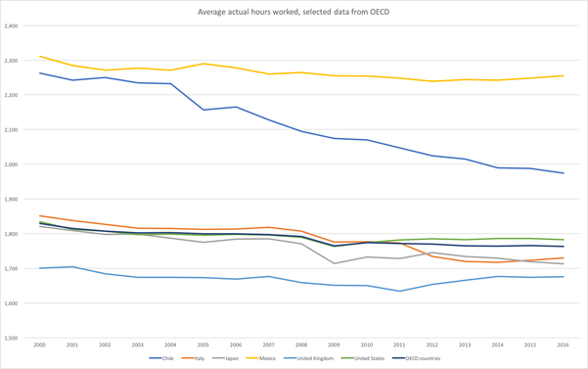

* OECD, 2017. Average annual hours actually worked per worker. Accessed at [*https://stats.oecd.org/Index.aspx?DataSetCode=ANHRS*](https://stats.oecd.org/Index.aspx?DataSetCode=ANHRS) 27th October 2017.

The drop in work times means that there has been an increase in leisure time in these countries. This drop in working hours is due to several factors:

1. Government regulation has limited the number of hours permitted for employers to expect employees to work. For example, the European Union’s Working Time Directive limits work to 48 hours per week (European Commission, 2017).
2. Increases in wages, especially due to the implementation of minimum wages, meaning fewer hours work will earn the same money. For example, Hong Kong introduced a minimum wage in 2011 that was increased in 2017 (Labour Department, 2017). However, in some societies long working hours are still required. For example, in El Salvador, the minimum wage varies according to the type of work being done and is only US$6.67 per day for picking cotton ([Ministerio De Trabajo Y Previsión Social, 2017](http://www.mtps.gob.sv/avisos/salarios-minimos-2018/))
3. Reduction in costs for basic needs (e.g. food) and luxuries (e.g. computers) reducing the amount of work required.
4. Greater acceptance of a five-day working week, especially for part-time staff.
5. Technological developments making non-leisure activities less time consuming, such as having a dishwasher to save time washing dishes.

These factors combine to make it easier for some workers to meet their needs while working fewer hours. However, since the financial crisis of 2009, many individuals have found that they have had to work more because their wages have not increased as fast as inflation.

Societal variation in leisure time

Gender

Women typically make up less of the formal workforce than men in most countries, as the map below shows (Pew Research Centre, 2017).

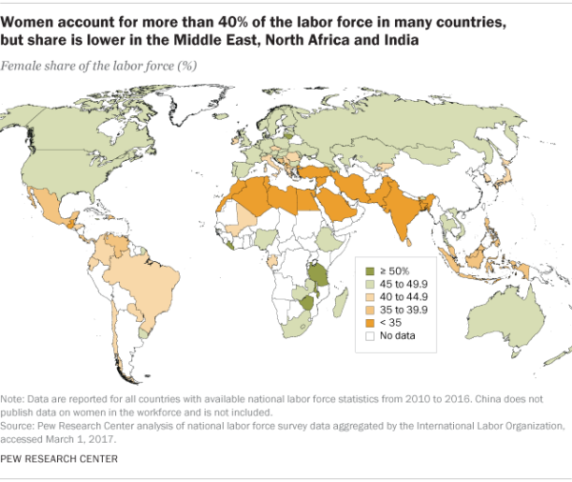

* Pew Research Centre, 2017. In many countries, at least four-in-ten in the labour force are women. Accessed at [*http://www.pewresearch.org/fact-tank/2017/03/07/in-many-countries-at-least-four-in-ten-in-the-labor-force-are-women/*](http://www.pewresearch.org/fact-tank/2017/03/07/in-many-countries-at-least-four-in-ten-in-the-labor-force-are-women/) 27th October 2017.

However, there is a leisure time gender divide in most societies with women typically having less leisure time than men. This is because women are more likely to be involved in informal employment, meaning that they are not counted in many of the statistics of employment. Also, women are more likely to take on the role of homemaker – looking after children, cooking the family meals, and cleaning.

Economic development

High Income Countries (HICs) are more likely to report higher leisure time than Middle- and Low-Income Countries (MICs and LICs). The graph below is from the World Economic Forum (2016) and shows that many HICs spend much less time at work, yet they earn much more per capita:

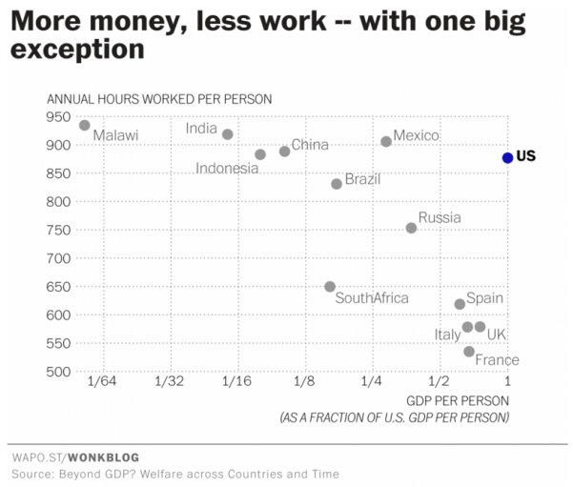

* World Economic Forum, 2016. Wealthier countries have more leisure time – with one big exception. Accessed at [*https://www.weforum.org/agenda/2016/02/wealthier-countries-have-more-leisure-time-with-one-big-exception*](https://www.weforum.org/agenda/2016/02/wealthier-countries-have-more-leisure-time-with-one-big-exception) 27th October 2017.

Reasons why HICs tend to work less include:

* The way that they consider work. Most employment in these countries is ‘formal’ employment – meaning it is taxed, regulated and reported. In non-HICs, work may be formal and therefore reported less accurately.
* The less money a person has, the more likely they are to need to work more hours to earn more money.
* Technology: Non-leisure activities that are automated in HICs may be done by hand in less well-off societies

The growth in tourism

Tourism is a huge growth industry. The United Nations World Tourism Organisation (UNWTO) reports annually on the numbers of tourists and the impact they have on the economy. In 2016, there were over 1,235 million international tourist arrivals, contributing 10% of global GDP, 7% of global trade and 10% of global employment (UNWTO, 2017). With 300 million more international tourists in 2016 than in 2008, there has been a clear and massive growth in this way of spending leisure time.

Patterns in tourism

This growth has not been evenly spread over time or space. The map below shows the changes in global tourism by region.

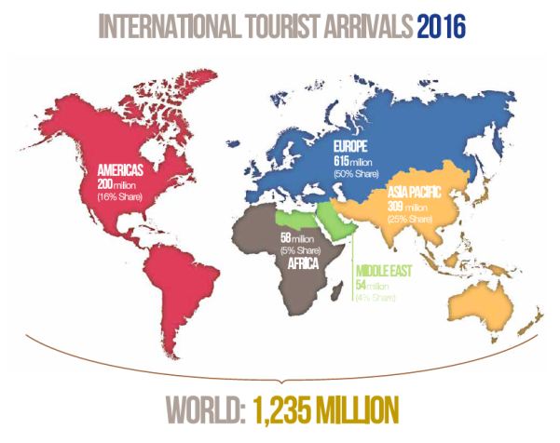

UNWTO, 2017a. United Nations World Tourism Organisation Annual Report 2016. UNWTO. Madrid.

There are many reasons why some world regions appear to have higher levels of international tourist arrival than others. For example, the European region has many countries in small area. It is easier to travel the distances required to be an international tourist in Europe than, say, the Americas. Also, one reason for international travel is to visit new places. In the Americas, there are large countries (Canada, USA, Brazil etc.) and it’s not necessary to visit another country in order to experience a different environment.

Trends in tourism

Nor has the trend in tourism been smooth. The cumulative graph below shows the variation in world tourism.

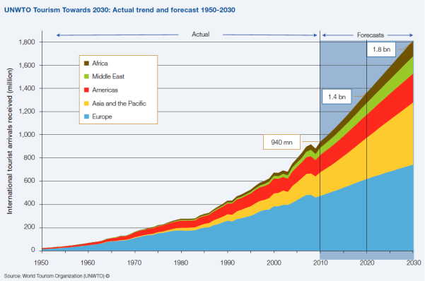

UNWTO, 2017b. United Nations World Tourism Organisation Tourism Highlights 2017 edition. UNWTO. Madrid.

All regions experience growth, but some will grow faster than others – especially Asia and the Pacific. The reasons for the continued growth in tourism are covered in detail in the page ‘Factors affecting participation’.

However, there have been dips. For example, in 2009, a significant dip occurred during the global economic crisis as wages and job security caused people to not travel. Other dips include in the early 2000s as terrorism concerns made people not want to travel; and in the early 1990s, the insecurity around the breakup of the Soviet Union was a further disincentive.

Reasons for the growth in tourism

There are two main reasons why tourism has grown:

**Demand**: There is a greater demand from people for tourism. As people have higher incomes, and as they have more leisure time, they want to travel to new places. This is also helped by technology such as TV, **social media**, online advertising, and online booking sites. Meanwhile, **diaspora growth** has meant that there are more people born in a different country to the one they live in, resulting in more travel for people to visit relatives.

**Supply**: There is a greater supply of tourist facilities worldwide – for example, most countries now have more tourist attractions compared to the past, and there are more hotels, restaurants and so on that make places suitable for tourism. This is sometimes due to a deliberate government policy to encourage tourism. Also, technology has increased the accessibility of new places through better transport and information systems. Also, there is a greater level of **international security,** so tourism is now offered to more destinations worldwide.

Burdett, M. (2017). Patterns and trends in leisure and tourism. Retrieved from https://geographycasestudysite.wordpress.com/patterns-and-trends-in-leisure-and-tourism/



1. Suggest how your leisure time (in terms of both duration and activity) might compare to:
2. A person of the opposite gender
3. A person at a lower level of economic advantage to you
4. A person in a low-income country
5. Outline the importance of tourism to the world economy.
6. Define ‘international tourist arrival’.
7. Describe the global distribution of international tourist arrivals.
8. What is the difference between demand for tourist resources and supply of tourist resources?
9. Briefly suggest why participation in tourism is increasing.

(200-300 words)

Case study:

Lime Scooters

A recent change you may have seen on the news is the story of Lime Scooters being trialled in Auckland and Christchurch. This has certainly been due to a gap being identified in the transportation market and the response to that gap has been Lime e-Scooters.

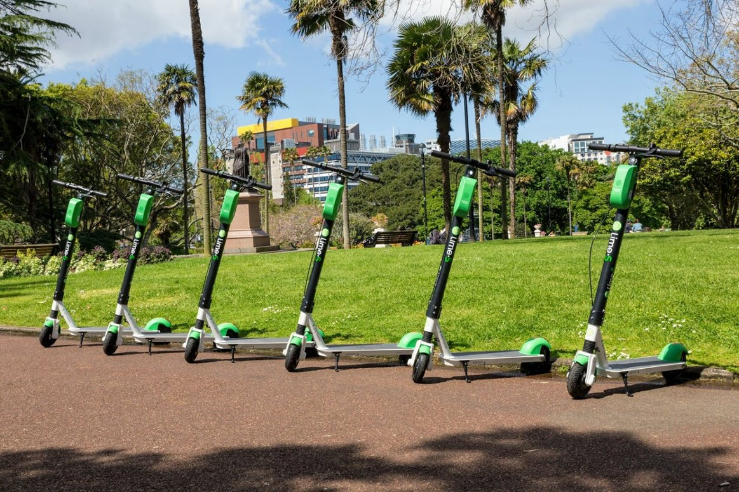

The advantage of these e-scooters is that they work in conjunction with existing public transport, allowing people to rely less on their own cars and helping to preserve the environment as well as enabling all walks of life to get from A to B whether it’s a business person in their suit headed to a meeting or a family exploring the city, these scooters make city mobility quick and easy.

At this stage in Auckland the trial has been extended through to the end of March 2019 before the council decides if these will be a permanent fixture of the city. Although there has been a few teething problems and some concerns around safety, Lime has committed to working further on safety-focused initiatives to increase responsible use of e-scooters.

The Lime e-scooters have certainly proven popular in Auckland, and there has been a significant growth in private ownership of e-scooters, as well as high uptake of these rental scooters, in the last few months. They are easily accessible and predominantly located in strategic locations throughout the city e.g. outside Britomart train station.

There has been an economic benefit for having these scooters, over 50 operations specialists were hired locally between Auckland and Christchurch as part of the company’s commitment to bring meaningful employment opportunities to all of its diverse markets. The company will also use locally-contracted ‘Juicers’ to pick up and charge the scooters overnight and then relocating them fully charged and ready to go.

So how do these e-scooters work?

To get started you would need to download the Lime App and you can visit the website for more information, <https://www.li.me/>

F:\SALES & MARKETING\ARTWORK\Workbook - Resources\Icons\Blue Monitor USE.png

How to Lime: Electric Scooters 1:00min

https://youtu.be/zOMYOBBRtM8

F:\SALES & MARKETING\ARTWORK\Workbook - Resources\Icons\Blue Monitor USE.png

How to Park a Lime-S Electric Scooter 1:00min

**https://youtu.be/Qb2s8A1KnRQ**



1. Go to the following webpage and read through the article:

<https://www.nzherald.co.nz/index.cfm?objectid=12188128&ref=twitter> or use the short URL: **https://bit.ly/3DzcnKN**

In groups identify the safety issues addressed in the article and discuss ways in which you think these could be addressed.

1. Your trainer will split you into a for and against e-scooter group. In your allocated group prepare a debate to argue your case for the e-scooters.

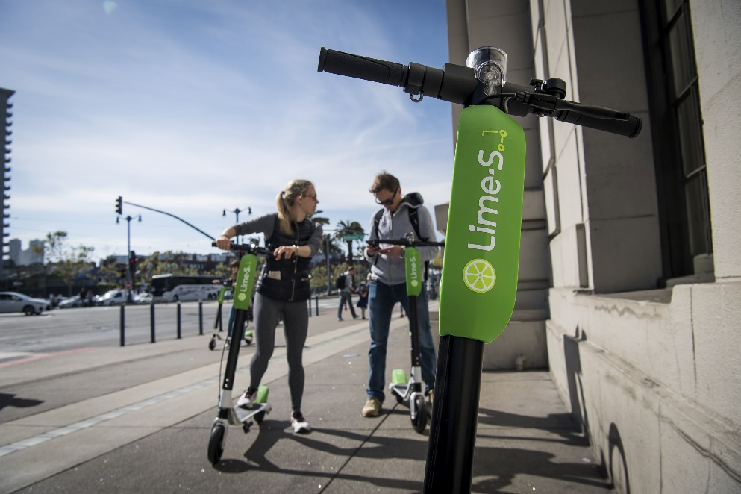

How to write a case study

A case study requires you to provide an in-depth investigation into an organisation, event, process or person. It is a method used to narrow down a very broad field of research into one easily researchable topic. Whilst it will not answer a question completely, it will give some indications and allow further elaboration and [hypothesis](https://explorable.com/research-hypothesis) creation on a subject.

A well-written case study requires planning and thought to properly analyse the situation and offer possible solutions.

The case study for this course requires you to investigate a response to change for a single instance e.g. the Lime Scooters in Auckland and use supporting evidence to identify and analyse if the implemented change was successful or not. Was there enough robust data to evaluate if the change made is working, if not what data should be collected? How do you know that the change made has made a difference or not?

1. Identify the change you are investigating e.g. need for easily accessible, cheap transport in the city.
2. Describe the target of your case study (person, organisation, event, process) and how this relates to your chosen change e.g. Lime scooters in Auckland.
3. Gather and present data that you locate in a desktop search that helps to evaluate if the change you are describing has been effective. Evaluate the quality of the data you are presenting, identify gaps, suggest other data to be collected.
4. Conclude if the change has been effective based on evidence (not opinion/impressions).
5. 

Further your research on Lime Scooters online e.g. NZ Herald articles and using what you have learnt throughout this workbook write a case study on Lime Scooters using the following framework:

1. Clearly Identify the change.
2. Describe the target of your case study.
3. Gather and present data that helps to evaluate if the change has been effective. What is your supporting evidence?
4. Make your conclusion on whether the change has been successful or not.

